FLOWCHARTS
Alerts, Dashboard, Data Analysis and Reports
Shape | Meaning
Oval | Start or end
Rectangle | Process or calculation
Diamond | Decision
Parallelogram | Input or output
Off-page connector | Continue in another flowchart
Flowcharts 4.6, 4.7a–4.7c and 4.8

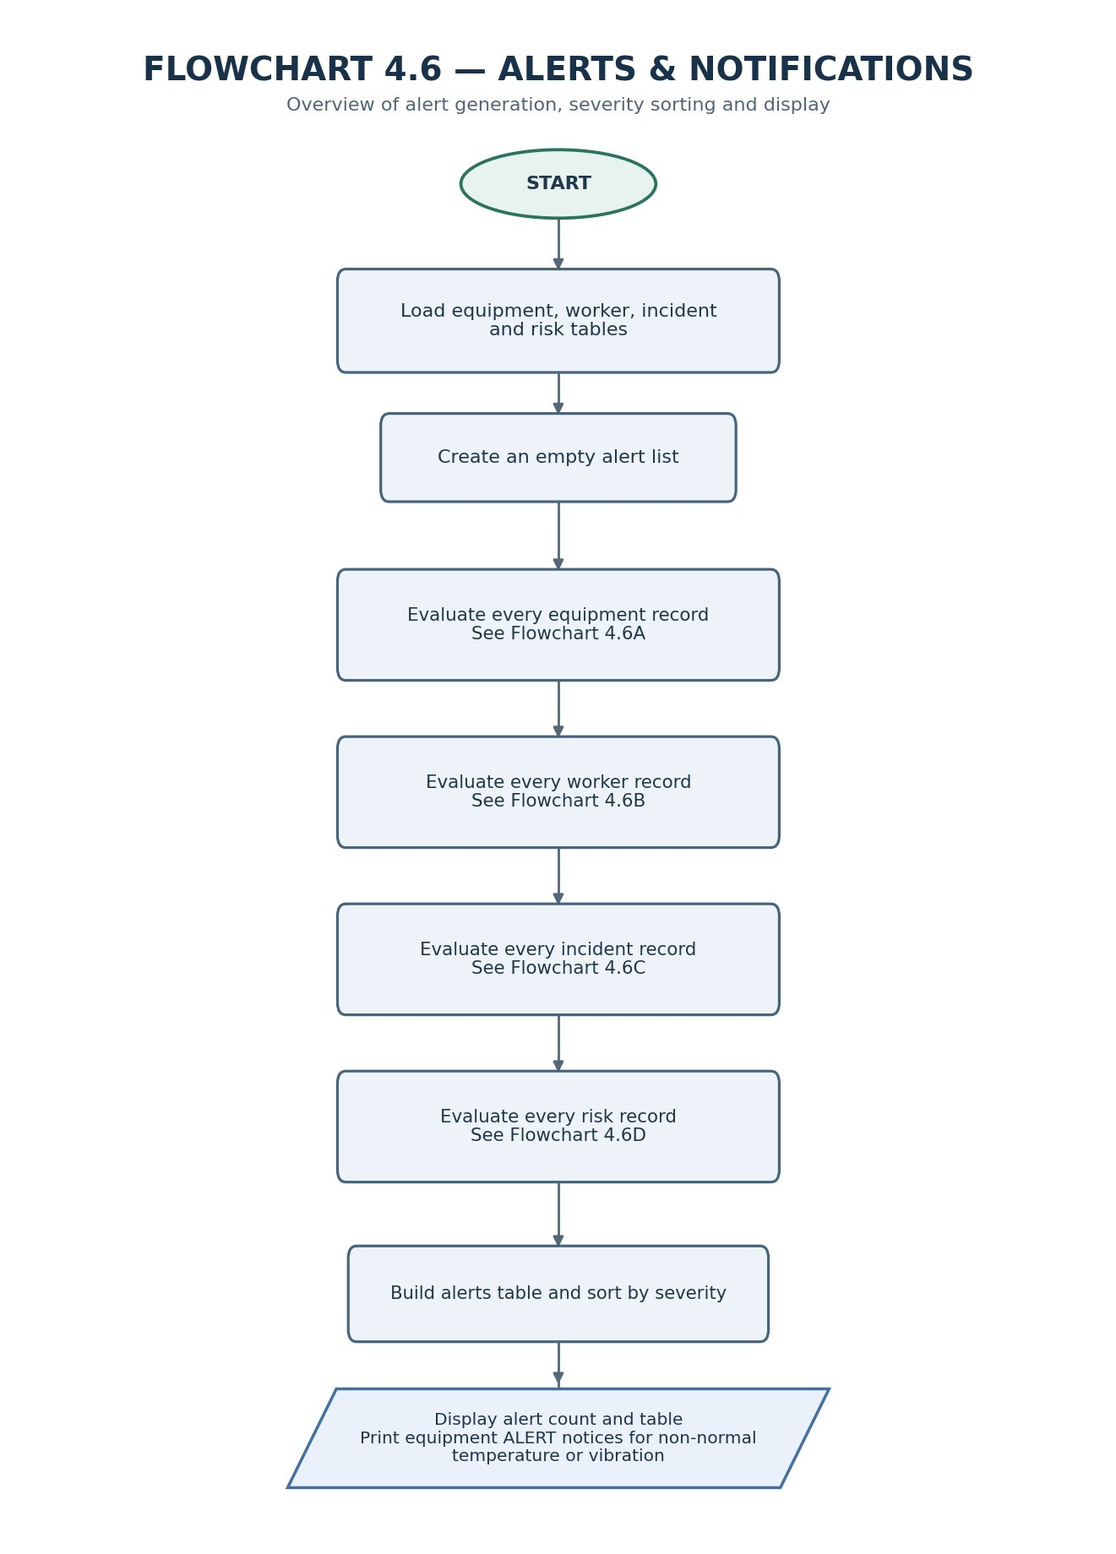

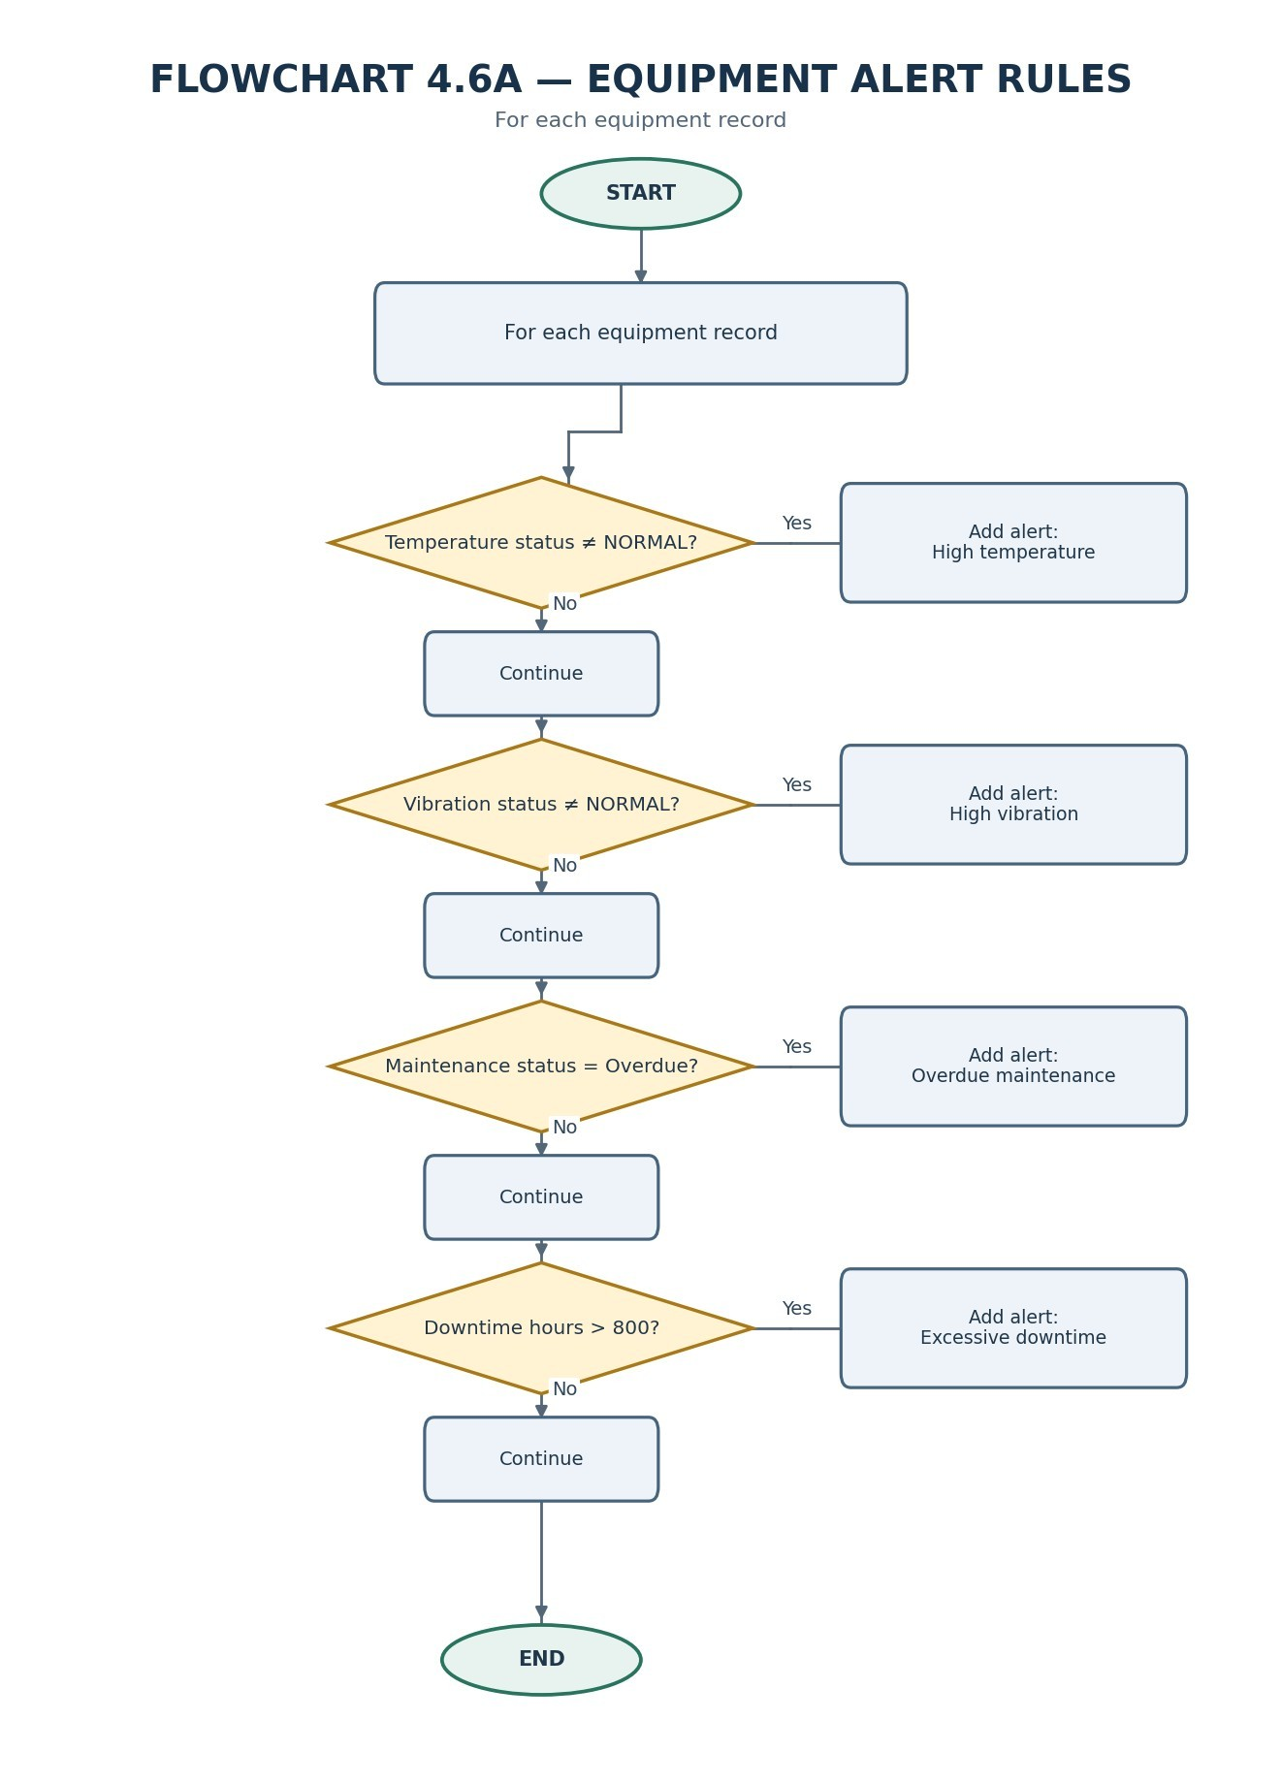

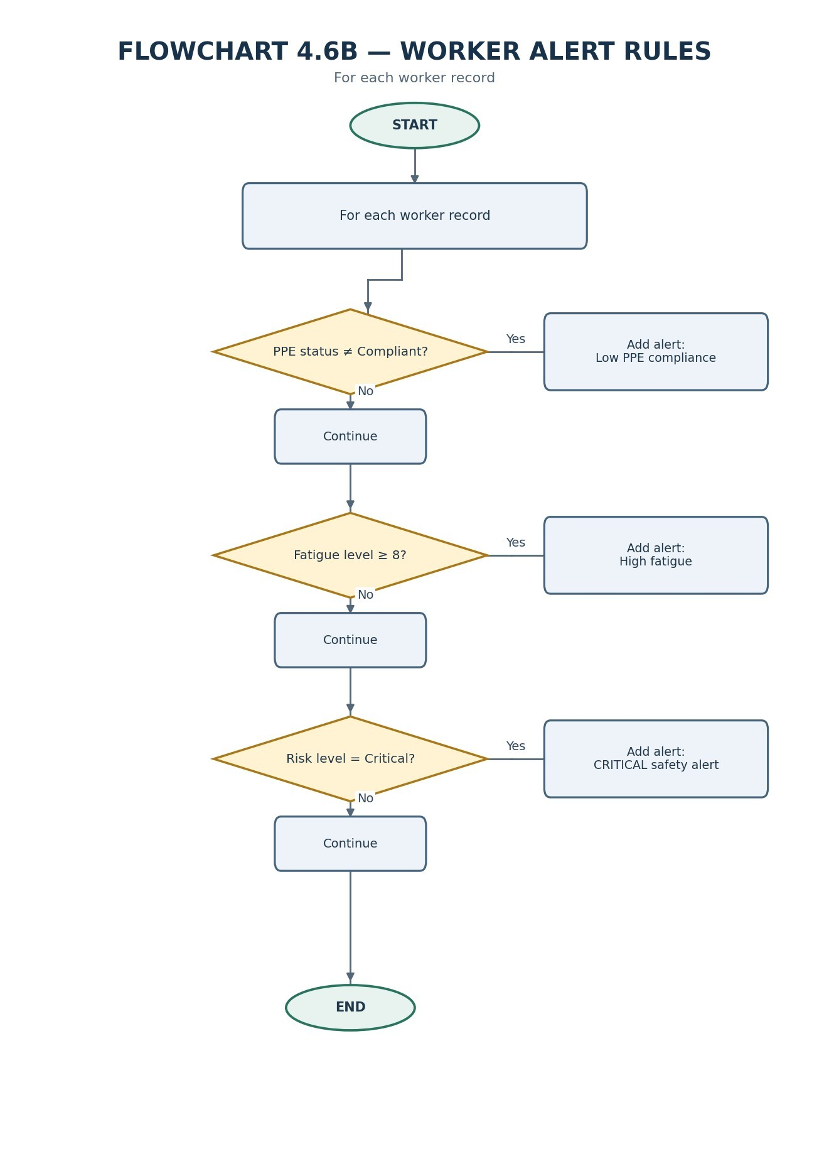

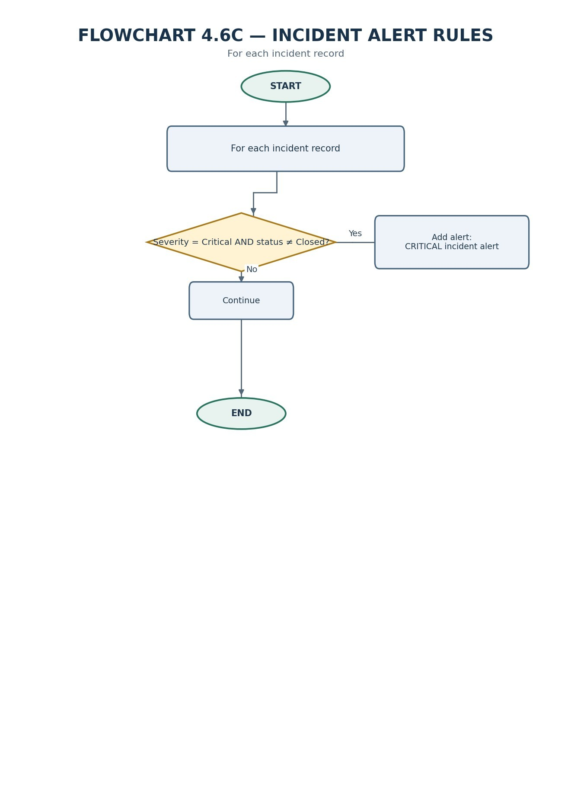

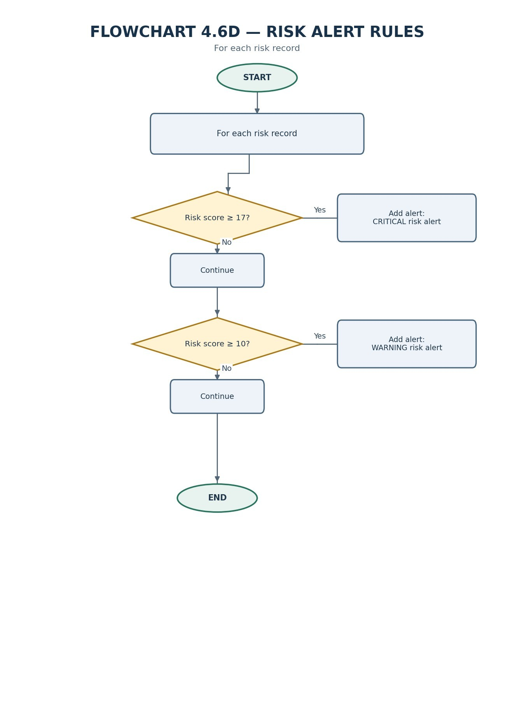

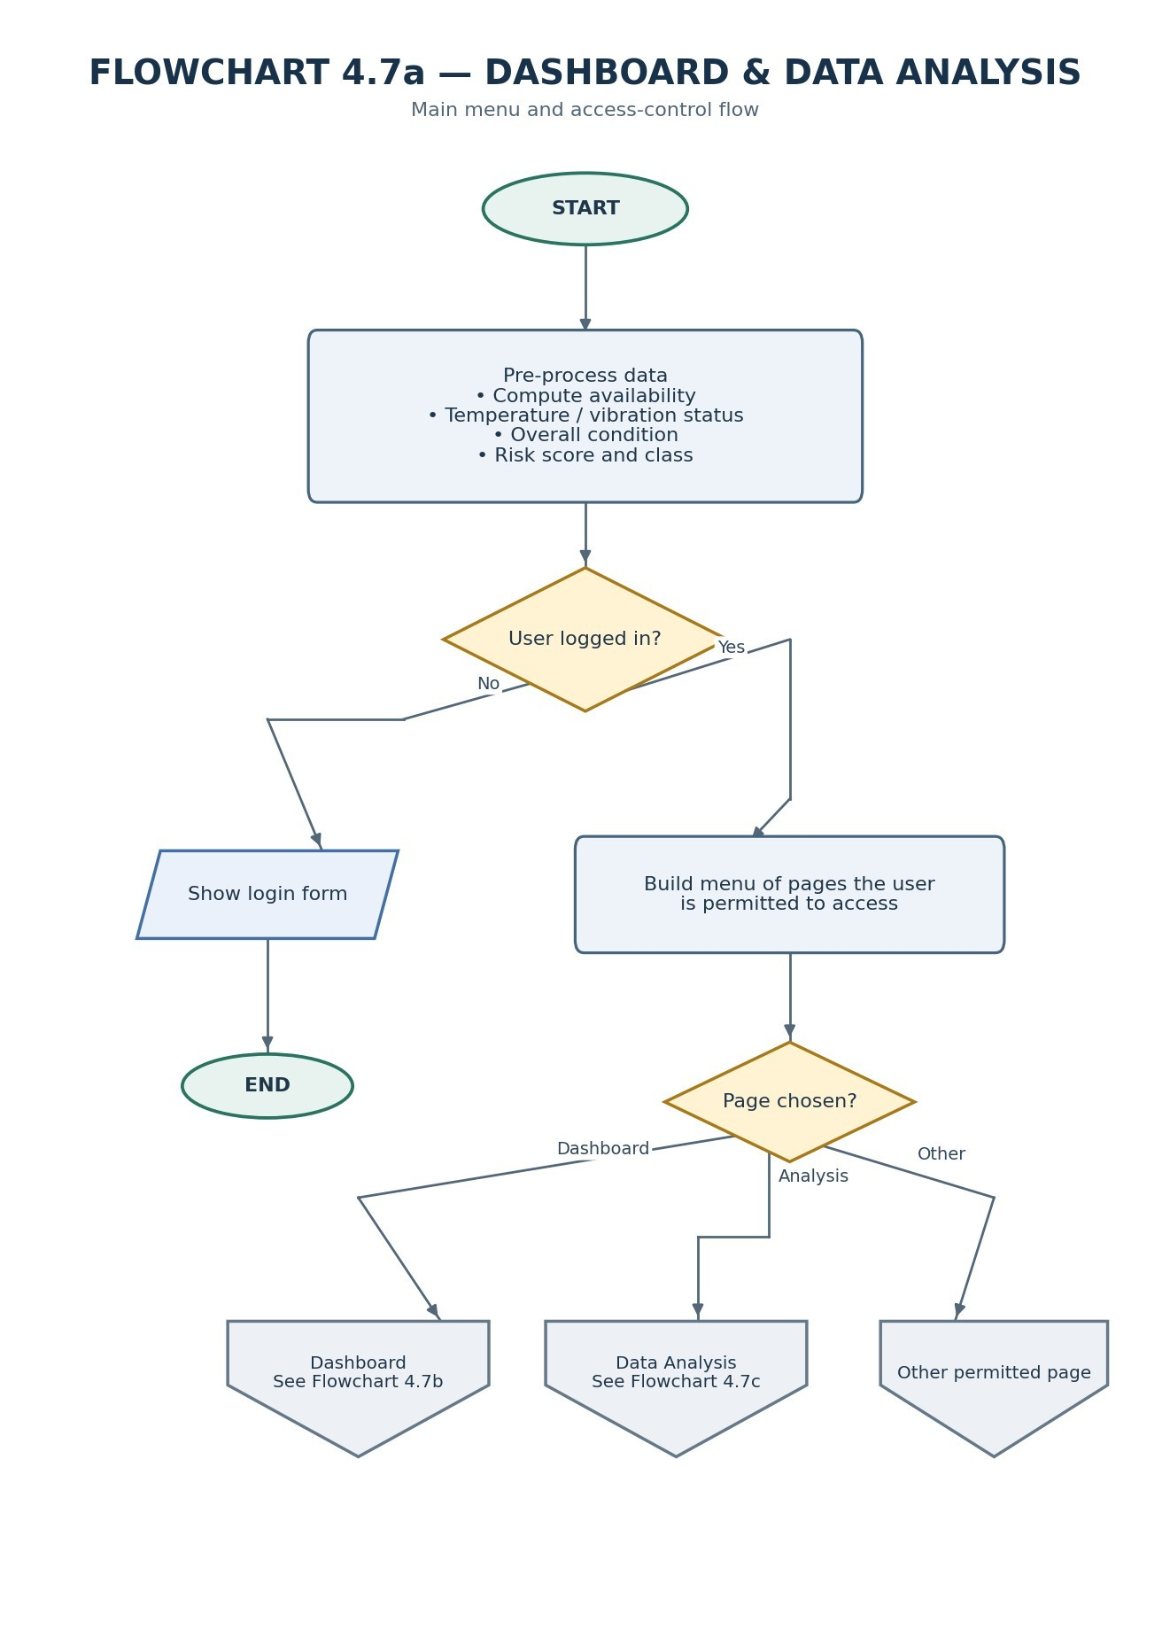

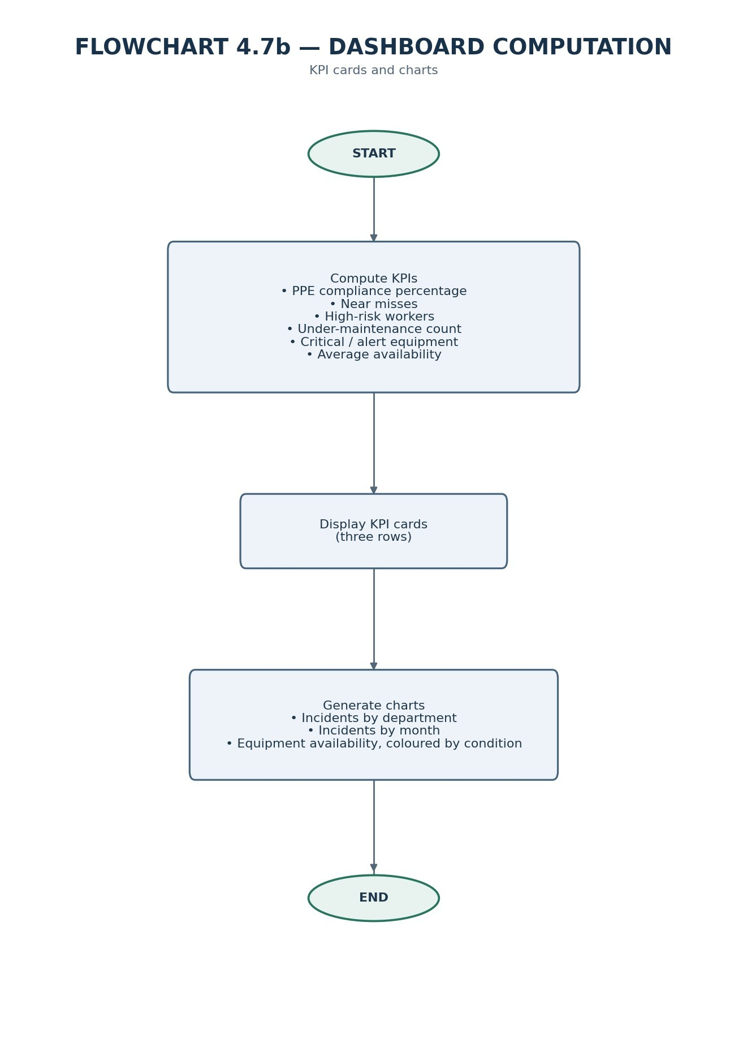

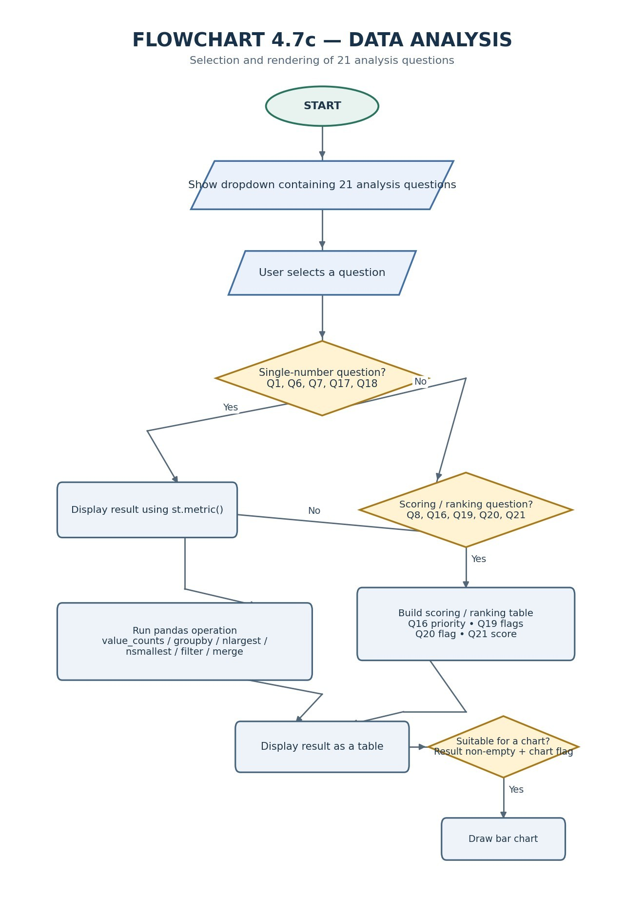

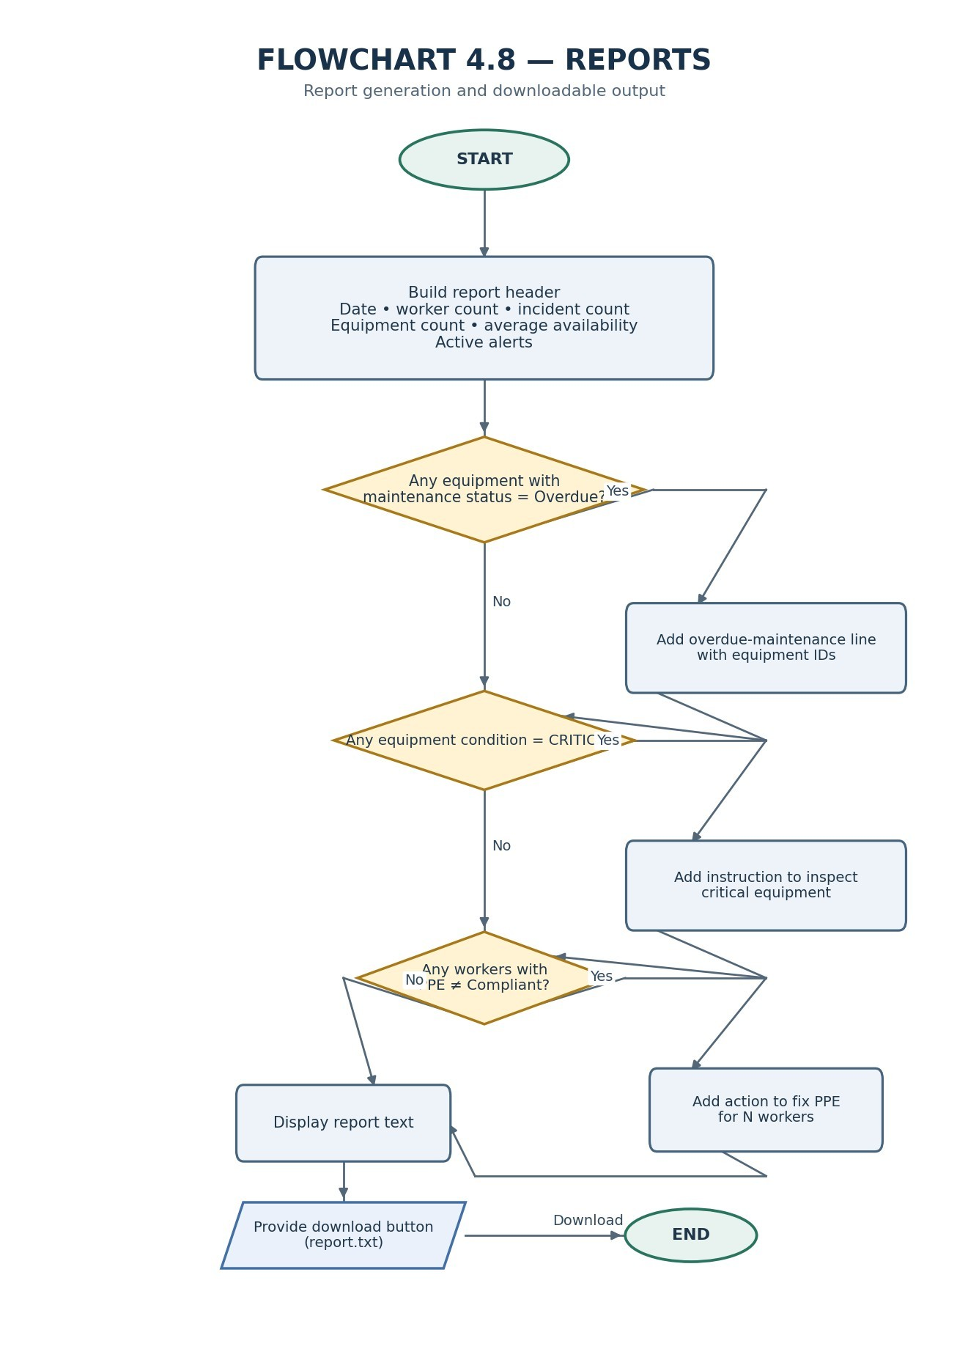

DOCUMENT 2 — PSEUDOCODE

2.1 Helper Functions (used by all sections)
text
FUNCTION get_temp_status(temp):
IF temp > 100 THEN RETURN "CRITICAL"
ELSE IF temp >= 80 THEN RETURN "WARNING"
ELSE RETURN "NORMAL"

FUNCTION get_vib_status(vib):
IF vib > 8 THEN RETURN "CRITICAL"
ELSE IF vib >= 5 THEN RETURN "WARNING"
ELSE RETURN "NORMAL"

FUNCTION get_availability(operating_hrs, downtime_hrs):
RETURN operating_hrs / (operating_hrs + downtime_hrs) * 100

FUNCTION get_risk_class(score):
IF score <= 4 THEN RETURN "Low"
ELSE IF score <= 9 THEN RETURN "Medium"
ELSE IF score <= 16 THEN RETURN "High"
ELSE RETURN "Critical"

FUNCTION count_table(column, label):
counts ← count occurrences of each value in column
RETURN table with columns [label, "Count"]

FUNCTION next_id(existing_ids, prefix, digits):
max_num ← 0
FOR EACH id IN existing_ids:
num ← integer part of id after prefix
IF num > max_num THEN max_num ← num
RETURN prefix + zero-padded (max_num + 1) to `digits` digits

FUNCTION can_access(role, function_name):
LOOKUP permission row where role=role AND function=function_name
RETURN (row exists AND row.allowed = "Yes")

2.2 Pre-processing (run once at start-up)
text
LOAD users, permissions, workers, incidents, equipment,
equipment_readings, equipment_alerts, maintenance_log,
risk_assessments

FOR EACH equipment row:
row.availability ← get_availability(operating_hrs, downtime_hrs)
row.temp_status ← get_temp_status(temperature_c)
row.vib_status ← get_vib_status(vibration_mm_s)
IF row.temp_status = "CRITICAL" OR row.vib_status = "CRITICAL" THEN
row.condition ← "CRITICAL"
ELSE IF row.temp_status = "WARNING" OR row.vib_status = "WARNING" THEN
row.condition ← "WARNING"
ELSE
row.condition ← "NORMAL"

FOR EACH risk row:
row.risk_score ← likelihood × consequence
row.classification ← get_risk_class(row.risk_score)

2.3 Alerts and Notifications (Section 4.6)
text
FUNCTION make_alerts():
alerts ← empty list

/* Equipment checks */
FOR EACH eq IN equipment:
IF eq.temp_status ≠ "NORMAL" THEN
ADD [eq.temp_status, eq.equipment_id,
"High temperature: " + eq.temperature_c + " C"]
IF eq.vib_status ≠ "NORMAL" THEN
ADD [eq.vib_status, eq.equipment_id,
"High vibration: " + eq.vibration_mm_s + " mm/s"]
IF eq.maintenance_status = "Overdue" THEN
ADD ["WARNING", eq.equipment_id, "Overdue maintenance"]
IF eq.downtime_hrs > 800 THEN
ADD ["WARNING", eq.equipment_id,
"Excessive downtime: " + eq.downtime_hrs + " h"]

/* Worker checks */
FOR EACH w IN workers:
IF w.ppe_compliance ≠ "Compliant" THEN
ADD ["WARNING", w.worker_id, "Low PPE compliance"]
IF w.fatigue_level >= 8 THEN
ADD ["WARNING", w.worker_id,
"High fatigue level: " + w.fatigue_level]
IF w.risk_level = "Critical" THEN
ADD ["CRITICAL", w.worker_id,
"High-risk safety observation"]

/* Incident checks */
FOR EACH inc IN incidents:
IF inc.severity = "Critical" AND inc.incident_status ≠ "Closed" THEN
ADD ["CRITICAL", inc.incident_id,
"Critical safety incident: " + inc.incident_type]

/* Risk checks */
FOR EACH r IN risks:
IF r.risk_score >= 17 THEN
ADD ["CRITICAL", r.risk_id, "Critical risk: " + r.hazard]
ELSE IF r.risk_score >= 10 THEN
ADD ["WARNING", r.risk_id, "High risk: " + r.hazard]

RETURN alerts SORTED BY severity

PROCEDURE display_alerts_page():
alerts_now ← make_alerts()
PRINT "Active alerts: " + LENGTH(alerts_now)
SHOW table(alerts_now)

PRINT "Equipment alert notices"
FOR EACH eq IN equipment:
IF eq.vib_status ≠ "NORMAL":
PRINT alert notice (vibration, value, recommended action)
IF eq.temp_status ≠ "NORMAL":
PRINT alert notice (temperature, value, recommended action)

2.4 Dashboard (Section 4.7, part i – overview)
text
PROCEDURE display_dashboard():
ppe_percent ← % of workers with ppe_compliance = "Compliant"
near_misses ← count of incidents where incident_type = "Near Miss"
high_risk ← count of workers where risk_level IN {"High","Critical"}
under_maint ← count of equipment where maintenance_status = "Under Maintenance"
critical_eq ← count of equipment where condition = "CRITICAL"
alert_eq ← count of equipment where condition ≠ "NORMAL"

/* Row 1 – people & incidents */
SHOW metric "Total workers" = LENGTH(workers)
SHOW metric "Safety incidents" = LENGTH(incidents)
SHOW metric "Near misses" = near_misses
SHOW metric "High-risk observations" = high_risk

/* Row 2 – PPE & equipment */
SHOW metric "PPE compliance (%)" = ROUND(ppe_percent, 1)
SHOW metric "Total equipment" = LENGTH(equipment)
SHOW metric "Equipment available" = LENGTH(equipment) − under_maint
SHOW metric "Under maintenance" = under_maint

/* Row 3 – alerts & availability */
SHOW metric "Equipment alerts" = alert_eq
SHOW metric "Critical equipment alerts" = critical_eq
SHOW metric "Average availability (%)" = ROUND(MEAN(equipment.availability), 1)

/* Charts */
DRAW bar chart: incidents by department
DRAW line chart: incidents per month (derived from date[:7])
DRAW bar chart: availability per equipment, coloured by condition

2.5 Data Analysis – (Section 4.7, part i – analysis)
text
PROCEDURE display_analysis():
precompute:
risk_by_dept = MEAN risk_score groupby department
downtime = SUM downtime_hrs groupby department

question ← user selection from list of 21 questions
result ← NULL
draw_chart← TRUE

SWITCH question:

CASE 1 "How many incidents occurred?"
SHOW metric "Total incidents" = LENGTH(incidents)

CASE 2 "Which department has the most incidents?"
result ← count_table(incidents.department)

CASE 3 "Which shift has the most incidents?"
result ← count_table(incidents.shift)

CASE 4 "Which incident types are most common?"
result ← count_table(incidents.incident_type)

CASE 5 "What are the most common causes?"
result ← count_table(incidents.cause)

CASE 6 "How many incidents are Major or Critical?"
big ← filter incidents WHERE severity IN {"Major","Critical"}
SHOW metric "Major or Critical incidents" = LENGTH(big)
result ← count_table(big.severity)

CASE 7 "What percentage of workers comply with PPE?"
SHOW metric "PPE compliance (%)" = ROUND(ppe%, 1)

CASE 8 "Which departments have the highest safety risk?"
result ← risk_by_dept SORTED BY avg_risk_score DESC

CASE 9 "Which equipment has the highest downtime?"
result ← top 10 equipment BY downtime_hrs DESC

CASE 10 "Which equipment has the lowest availability?"
result ← bottom 10 equipment BY availability ASC

CASE 11 "Which equipment has the highest vibration?"
result ← top 10 equipment BY vibration_mm_s DESC

CASE 12 "Which equipment has the highest temperature?"
result ← top 10 equipment BY temperature_c DESC

CASE 13 "Which equipment has the most alerts?"
result ← top 10 equipment BY alert count (alerts_log) DESC

CASE 14 "Which equipment type has the highest downtime?"
result ← SUM downtime_hrs groupby equipment_type, sorted DESC

CASE 15 "Which equipment requires immediate inspection?"
result ← equipment WHERE condition = "CRITICAL"
(show id, temperature, vibration)

CASE 16 "Which equipment should receive maintenance priority?"
FOR EACH eq:
points ← 0
IF maintenance_status = "Overdue" THEN points += 3
IF maintenance_status = "Due for Maintenance" THEN points += 2
IF condition = "CRITICAL" THEN points += 3
ELSE IF condition = "WARNING" THEN points += 1
IF availability < 85 THEN points += 1
IF alert_count_30d >= 10 THEN points += 1
store [eq.equipment_id, points]
result ← top 10 sorted BY points DESC

CASE 17 "What percentage of equipment is operating normally?"
pct ← % of equipment WHERE condition = "NORMAL"
SHOW metric "Operating normally (%)" = ROUND(pct, 1)

CASE 18 "How many critical alerts are currently active?"
critical_alerts ← filter make_alerts() WHERE severity = "CRITICAL"
SHOW metric "Critical alerts active" = LENGTH(critical_alerts)
result ← critical_alerts
draw_chart ← FALSE

CASE 19 "Which safety indicators require management intervention?"
indicators ← list of [name, value, target, flag] where flag =
"ACTION NEEDED" if value outside target, else "OK":
PPE compliance % (target ≥ 90)
Workers with fatigue ≥8 (target ≤ 3)
Workers with expired training (target = 0)
Open critical incidents (target = 0)
Lost-time injuries (target ≤ 10)
result ← table(indicators)
draw_chart ← FALSE

CASE 20 "Which departments have both high safety risk and high downtime?"
result ← merge(risk_by_dept, downtime, ON department)
risk_mean ← MEAN(result.avg_risk_score)
down_mean ← MEAN(result.total_downtime)
flagged ← rows where BOTH scores > their respective means
PRINT "Above average on both: " + list(flagged.departments)

CASE 21 "Which areas require the greatest attention?"
merge incidents-by-dept, risk_by_dept, downtime
attention_points ← rank(incidents) + rank(avg_risk_score) + rank(downtime)
result ← rows sorted BY attention_points DESC

END SWITCH

IF result ≠ NULL THEN
SHOW table(result)
IF draw_chart = TRUE AND LENGTH(result) > 0 THEN
DRAW bar chart with result.columns[0] on X, columns[1] on Y,
title = question

2.6 Reports (Section 4.8)
text
PROCEDURE generate_report():
lines ← [
"MINING SAFETY SUMMARY - " + TODAY,
"Workers: " + LENGTH(workers),
"Incidents: " + LENGTH(incidents),
"Equipment: " + LENGTH(equipment) +
", average availability " + ROUND(MEAN(availability),1) + "%",
"Active alerts: " + LENGTH(make_alerts()),
"",
"RECOMMENDATIONS"
]

overdue ← equipment WHERE maintenance_status = "Overdue"
IF LENGTH(overdue) > 0 THEN
APPEND "- Do overdue maintenance on: " + join(overdue.ids)

critical ← equipment WHERE condition = "CRITICAL"
IF LENGTH(critical) > 0 THEN
APPEND "- Inspect critical equipment now: " + join(critical.ids)

bad_ppe ← workers WHERE ppe_compliance ≠ "Compliant"
IF LENGTH(bad_ppe) > 0 THEN
APPEND "- Fix PPE problems for " + LENGTH(bad_ppe) + " workers"

report ← join(lines, newline)
DISPLAY report in text area
PROVIDE download button that saves report as “report.txt”

